

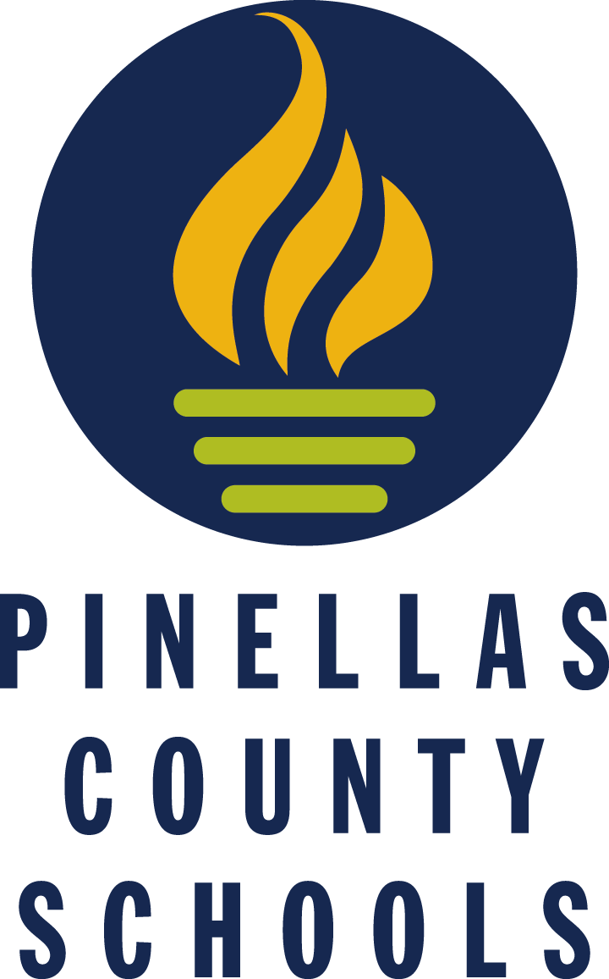
An exploratory program designed to introduce high school students to career opportunities in the occupational clusters of Engineering, Design and Architecture, Manufacturing, Mechanics, and Construction. Upon completion, students will be eligible for Immersive Dual Enrollment ( I D E ) at Pinellas Technical College during their senior year (upon completion of graduation requirements).

G R A D E 9 : D R A F T I N G A N D D E S I G N
Demonstrate the ability to work safely with a variety of technologies.
Recognize the design process; including defining a problem, brainstorming, researching and generating ideas, identifying criteria and specifying constraints, exploring possibilities, selecting an approach, developing a design proposal, making a model or prototype, testing and evaluating the design using specifications, refining the design, creating or making it, and communicating processes and results.
Demonstrate an understanding of the role of troubleshooting, research and development, invention and innovation, and experimentation in problem solving.
Demonstrate an understanding of engineering design.
Demonstrate an understanding of and be able to select and use construction technologies.
Apply basic skills in communications, mathematics, and science appropriate to technological content and learning activities .
Demonstrate and apply design/problem-solving processes.
Explain the career opportunities in the Construction and Design sectors.

8600510 Technology Studies I Exposure to AutoCAD programs, hand and power tools use

G R A D E 1 0 : E L E C T R I C I T Y & F L U I D D Y N A M I C S

Demonstrate knowledge and application of electrical systems.
Categorize types of energy into major forms: thermal, radiant, electrical, mechanical, chemical, nuclear, and others.
Demonstrate an understanding of and be able to select and use energy and power technologies. Name the six basic parts of the energy system.
Demonstrate knowledge and application of fluid systems. Understand the fundamentals of an air conditioning system.
Describe the heat transfer process of an air conditioning and heating system. Understand fluid power in a basic hydraulic system (Pascals Theory) .
Demonstrate an understanding of the laws of electrical energy (Ohms and Watts Laws). Design and build basic electrical circuits (12 volt and 120 volt).
Explain the difference between Direct Current and Alternating Current (AC/DC). Explain Welding processes.
Explain the career opportunities in the electrical, HVAC and hydraulics/pneumatics sectors.
8600610 Technology Studies II Exposure to Soldering, Safety and Procedures.

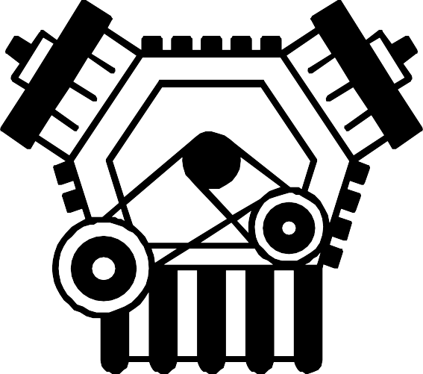
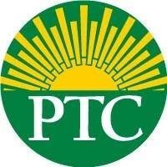
Welding
Plumbing
Marine Mechanics
Electricity
Heavy Equipment Operation
Diesel Truck Technology
Building and Construction
Automotive Collision Repair
Heating, Ventilation, and Air Conditioning
Automotive Technology
Cabinet Making

G R A D E 1 1 : M E C H A N I C S
Demonstrate an understanding of and be able to select and use transportation technologies.
Demonstrate knowledge and application of mechanical systems.
Explain the cycles of 2 stroke and four stroke internal combustion engines.
Explain the similarities and differences between diesel and gasoline engine combustion processes.
Identify automotive mechanical systems.
Explain gear ratios, gear reduction, overdrive and mechanical advantage.
Identify the maintenance requirements of common internal combustion engine machines. Apply troubleshooting to basic electrical systems on common machines.
Explain the career opportunities in the mechanics, maintenance and repair sectors.
8601710 Technology Studies III Expose to Industry Tools, Preventive Maintenance

GRADE 12: IMMERSIVE DUAL ENROLLMENT AT
PINELLAS TECHNICAL COLLEGE
Acceleration Points Earned

Public Works
Computer Aided Design and Drawing

